Computer Networking – Week 2
What is a network?
A network is simply two or more devices that have been connected to each other
Modern form of communication for humans
Roads => Unlike traditional roads they are superfast
Network infrastructure is the lifeblood in modern organizations

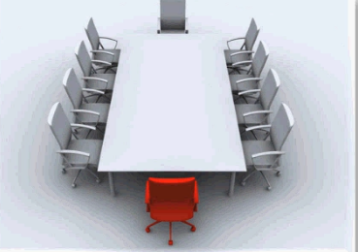

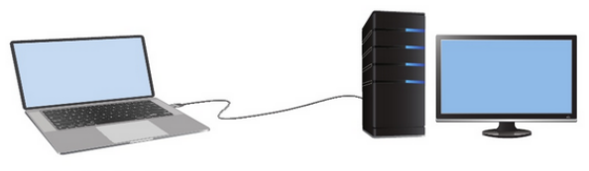

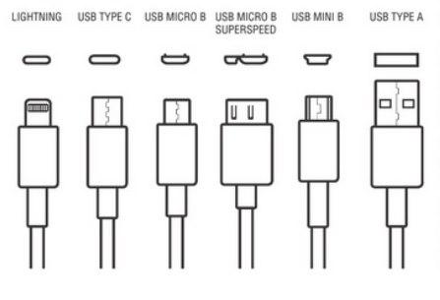

Network Components | Building blocks
A network can contain a range of different components, with each having a defined role in the network.
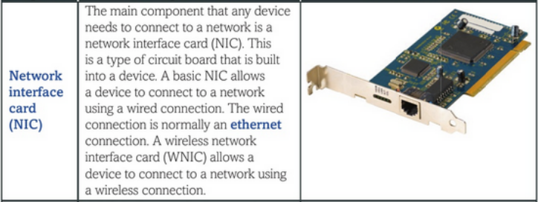

Ethernet is the most common type of wired network connection.
NIC – A piece of hardware that is built into a device. It allows it to have a wired or wireless connection.
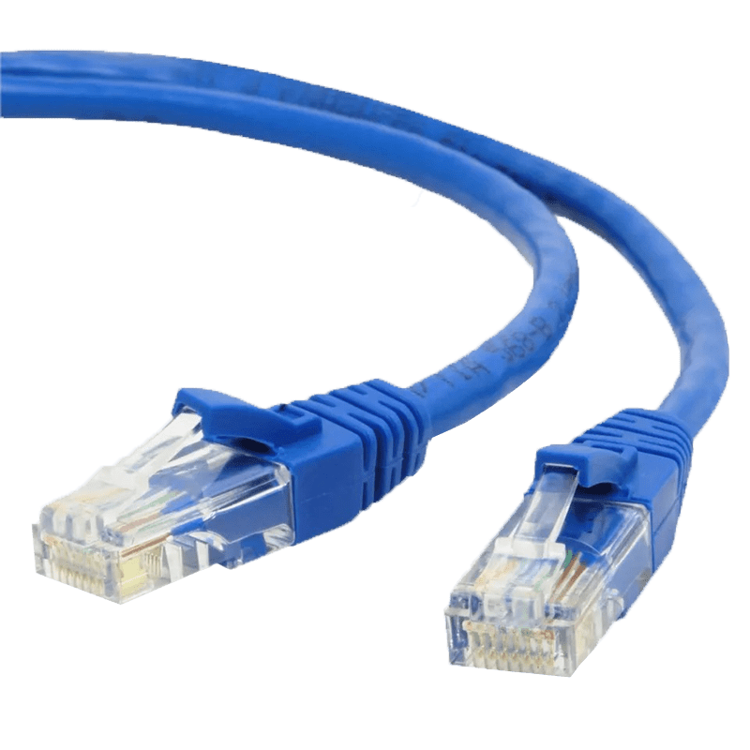
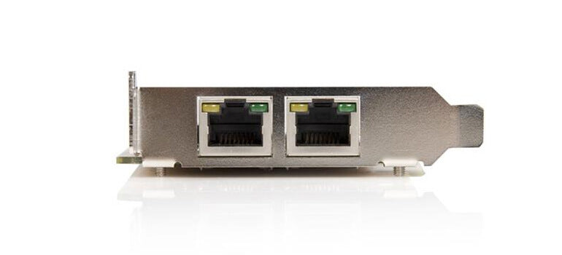

Modern computers usually have NICs built into the motherboard, but you can still add one if needed.

Inside the organization

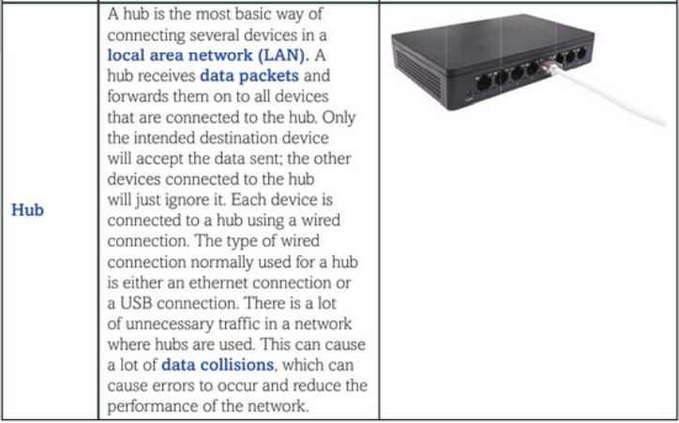

LAN – Type of network that is located within a single building or site
Data packet – The unit of data that contains the information to be transmitted across a network
Data collision – When two devices on a network send data simultaneously the data packets can collide

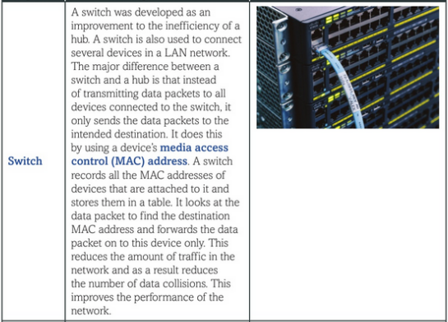

Outside the organization

MAC (Media access control) Address – A unique address that is given to the NIC in each device at the point of manufacture

IP Address – A unique address that is given to a device when it connects to a network

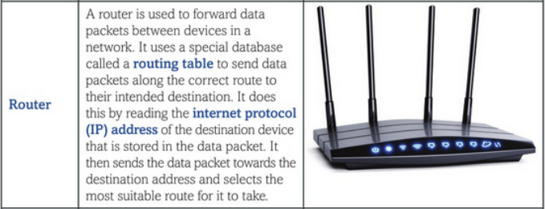

Allows us to communicate to a WAN (Wider area network)

Is the dividing line between your network and the other network

Router – Network hardware that reads IP addresses to send data to the correct network or device
Routing table – A database that stores all the known routes across a network to different devices.

Wireless Communication

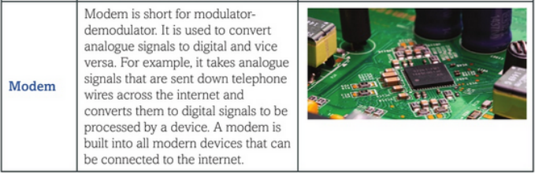

Modem – Network hardware that converts between analogue and digital signals.A

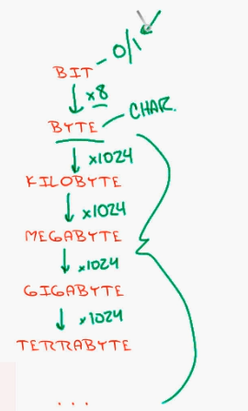

Speed – Bits / Second

OSI Model

